Histogram by Excel 2013

1. Copy the column of the data you need to another column and then sort the values.

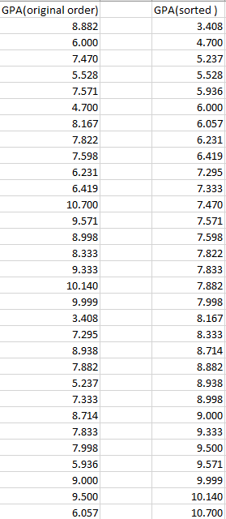

1. Create bins in a new column, choose a range with lower limit little bit smaller than the smallest value of the data and the upper limit little bit bigger than the biggest value of the data.
2. Equally divide the range above into groups (# of groups = sqrt(n)), and write down the limit point in each group.

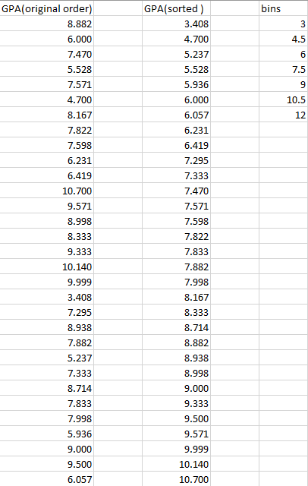

2. Data🡪 data analysis🡪histogram🡪ok, you will get the window below.

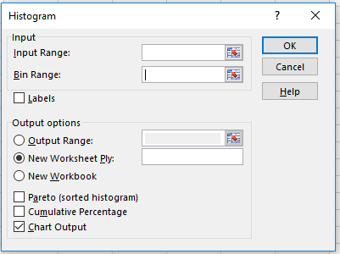

Click input range “”,



select the range of your data (don’t select the title), you will get



Click “”, you will get

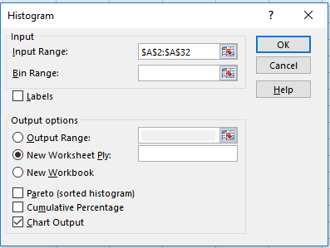

Click bin rang “” , you will get



select the range of bins (don’t select the title), you will get

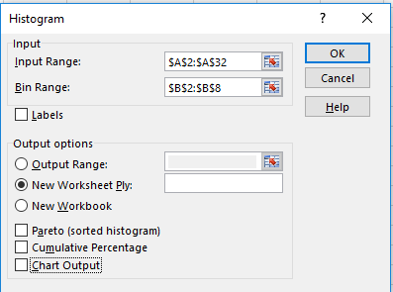

Click “Chart output”🡪 ok. You will get the graph below

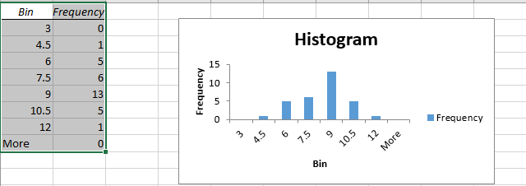

Right click any bar-🡪Format data series🡪change “gap width” to 0.

You will get the histofram you want.

